**INTERNET OF THINGS LAB RECORD**

**Subject code : BTCS-AMDS-SP8T**

|  |  |
| --- | --- |
| **Name:** | NANDINI ROUT |
| **Registration Number:** | FET-BAML-2022-2026-016 |
| **Course:** | Btech CSE AIML |
| **Semester:** | 5th |
| **Faculty:** | Mr Biswajeeban Mishra |

|  |  |
| --- | --- |
| **Remarks** |  |
| **Signature** |  |

SRI SRI UNIVERSITY

Bidyadharpur, Cuttack, Odisha.

|  |  |  |  |  |
| --- | --- | --- | --- | --- |
| **Sl. No.** | **Date** | **Experiment/Case Study** | **Page No.** | **Remark** |
| **1** | 7-8-2024 | **Blinking the inbuilt LED** |  |  |
| **2** |  |  |  |  |
| **3** |  |  |  |  |
| **4** |  |  |  |  |
| **5** |  |  |  |  |
| **6** |  |  |  |  |
| **7** |  |  |  |  |
| **8** |  |  |  |  |
| **9** |  |  |  |  |
| **10** |  |  |  |  |
| **11** |  |  |  |  |
| **12** |  |  |  |  |
| **13** |  |  |  |  |
| **14** |  |  |  |  |
| **15** |  |  |  |  |
| **16** |  |  |  |  |

**Experiment No.:1 Date: 7/8/2024**

1. Blink Inbuilt LED of Your Board and Explain the Program.

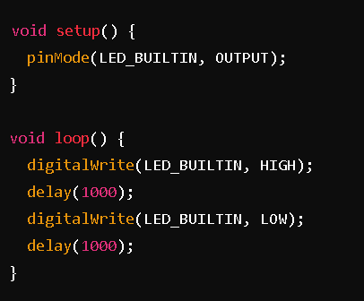

**Explanation**:

* pinMode(LED_BUILTIN, OUTPUT);: Configures the built-in LED pin as an output.
* digitalWrite(LED_BUILTIN, HIGH);: Turns the LED on.
* delay(1000);: Waits for 1 second.
* digitalWrite(LED_BUILTIN, LOW);: Turns the LED off.
* delay(1000);: Waits for 1 second.

**2. Explanation of LED_BUILTIN, OUTPUT, INPUT, LOW, HIGH**

These are macro definitions:

* **LED_BUILTIN**: Refers to the built-in LED pin.
* **OUTPUT**: Configures a pin as an output.
* **INPUT**: Configures a pin as an input.
* **HIGH**: Sets a pin to a high voltage level (5V).
* **LOW**: Sets a pin to a low voltage level (0V).

**Macro Definition**: A macro is a named constant or code that simplifies programming. Defined using #define. It replaces code with a value or statement.

**3. Purpose of the setup() Function**

The setup() function runs once at the start of the program. It is used to initialize settings like pin modes.

**4. Purpose of pinMode() in setup()**

The pinMode() function in setup() sets a pin as an input or output, determining how it will be used in the program.

**5. Role of the loop() Function**

The loop() function runs repeatedly after setup() and contains the main code to be executed continuously.

**6. What does the digitalWrite() Function Do?**

The digitalWrite() function sets a digital pin to HIGH (5V) or LOW (0V).

**7. Significance of LED_BUILTIN**

LED_BUILTIN is a macro that represents the pin number of the built-in LED on the Arduino board.

**8. Purpose of delay() in loop()**

The delay() function pauses the program for a specified time (in milliseconds), controlling how long the LED stays on or off.

**9. Difference Between setup() and loop()**

* **setup()**: Runs once for initialization.
* **loop()**: Runs continuously after setup().

**10. Effect of Changing delay(1000) to delay(500)**

If changed, the LED will blink faster, staying on for half a second and off for half a second.

**11. Significance of HIGH and LOW in digitalWrite()**

* **HIGH**: Turns the LED on.
* **LOW**: Turns the LED off.

**12. Modify Code for LED to Stay On for 2 Seconds and Off for 1 Second**